**WWF – Audit Tracking**

**Functional Requirements & Design (FRD) Document**

(Version 1.0)

***Document Overview***

|  |  |  |  |
| --- | --- | --- | --- |
| Title | FRD_Audit Tacking_V1.docx | Version | V1 |
| Project | WWF – Audit Tracking | Status | Released |
| Client | Mr. Samuel | Type | Internal / External |
| Author | Mr. Rajendra | Last Save | 06-06-2018 |
| Reviewed By | Mr. Keerthi Venkatesh | | |  |
| Comments: | | | |
|  | | | |

***Revision History***

|  |  |  |  |  |
| --- | --- | --- | --- | --- |
| **Ver. #** | **Rev Date** | **Author** | **Dist. Date** | **Brief Description** |
|  |  |  |  |  |
|  |  |  |  |  |
|  |  |  |  |  |

***Distribution List***

1. ***Baryons Stakeholders***
2. ***Delivery Team***

***Approved By***

|  |  |  |
| --- | --- | --- |
| **Name** | **Role** | **Version** |
|  |  |  |
|  |  |  |
|  |  |  |
|  |  |  |

Contents

1. Context: 5

2. Admin Login and Logout 6

3. User Role 6

4. Audit Type Master Creation 6

5. Audit Type Master List/Update 7

6. Audit Department Master Creation 8

7. Audit Department List/Update 9

8. Audit Add/List/Edit/Search 9

9. Listing Office Information 11

10. Email Notifications 11

11. Reports 11

12. SSO Integration 11

13. Database Design 12

Table of Contents of User Stories

|  |  |
| --- | --- |
| **SL No** | **User Stories** |
| 1 | Admin Login and Logout |
| 2 | User Role |
| 3 | Audit Type Master Creation |
| 4 | Audit Type Master List/Update |
| 5 | Audit Department Master Creation |
| 6 | Audit Department List/Update |
| 7 | Audit Add/List/Edit/Search |
| 8 | Listing Office Information |
| 9 | Email Notifications |
| 10 | Reports |
| 11 | SSO Integration |

# Context:

To enable WWF Network management to track the implementation of audit recommendations (internal audit, external audit, donor audit).

The application will be owned by the Network Audit Group and associated organizations (currently WWF Int, WWF US and WWF UK but may expand so software needs to be flexible)

Baryons must create the frontend application which will use MSSQL as backend. Baryons will develop the frontend using PHP MVC Framework (CodeIgniter)and other web technologies like HTML 5, CSS (Bootstrap framework), jQuery.

# Admin Login and Logout

As an Administrator need to browse the Audit application URL and login successfully so that I can access the application and logout successfully.

# User Role

1. The system will have three roles named

* **Creator**
* **Viewer**
* **Auditor**

1. The system users will be fetched from the “INSIGHT_USER” table. Once the user is logged into the system through SSO will show all the Office information owned by the user.
2. Logged in user will have viewer role, can only view the audit assigned to him.
3. Auditors can only open or edit the audits created by them. Auditors cannot open or edit the audits created by other auditors.
4. Auditors in WWF organizations should be able to see the information recorded against all recommendations (open and closed) arising from their own and their teams audit reports and should be able to selectively grant access to this information to other auditors

# Audit Type Master Creation

As an administrator, need to create Audit Types in the Audit Type Master so that the created list of values should able to list and selected while Audit Add.

**HOME -> Master->Audit Type**

1. **AUDIT_TYPE_ID**
2. **AUDIT_TYPE_NAME**

Audit Type is selected while creating an Audit.

Predefined Values are:

1) Internal

2) External

3) Donor

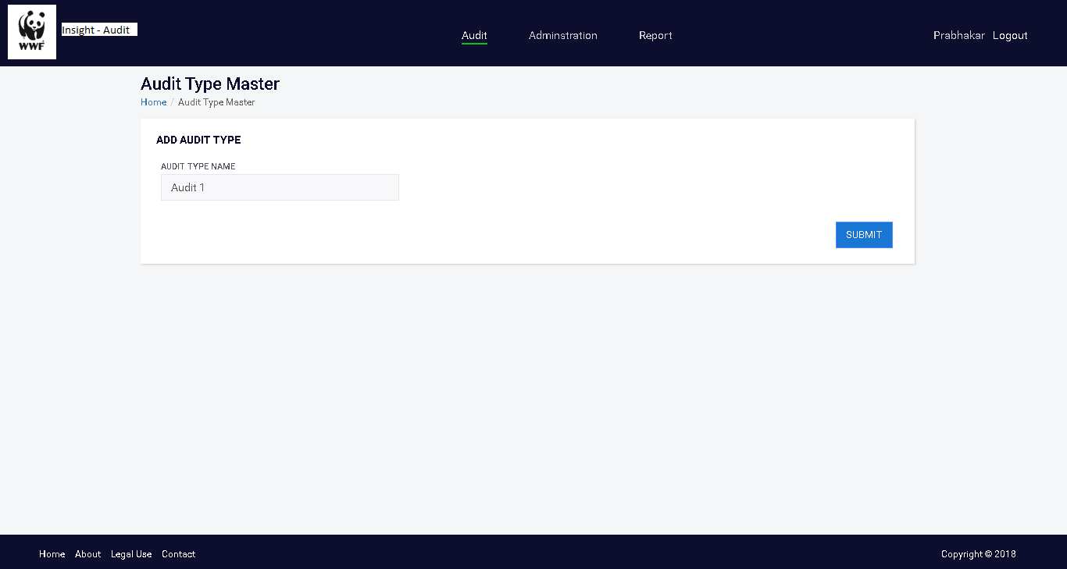

# Audit Type Master List/Update

As an administrator, need to get the list of Audit Types created so that the Audit Type can be viewed, and any update should be made.

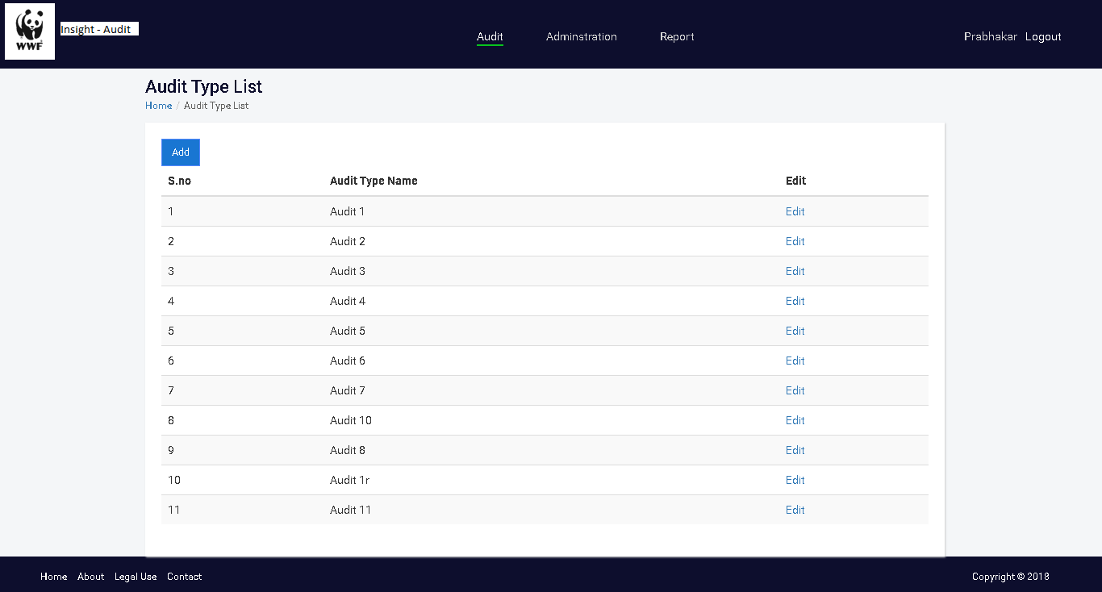

# Audit Department Master Creation

As an administrator, need to create Audit Departments in the Audit Department Master so that the created list of values should able to list and selected while Audit Add.

**HOME -> Master->Department**

1. **DEPARTMENT_ID**
2. **DEPARTMENT_NAME**

Department will be selected while creating an Audit.

Predefined Values are:

1. Finance
2. Operations

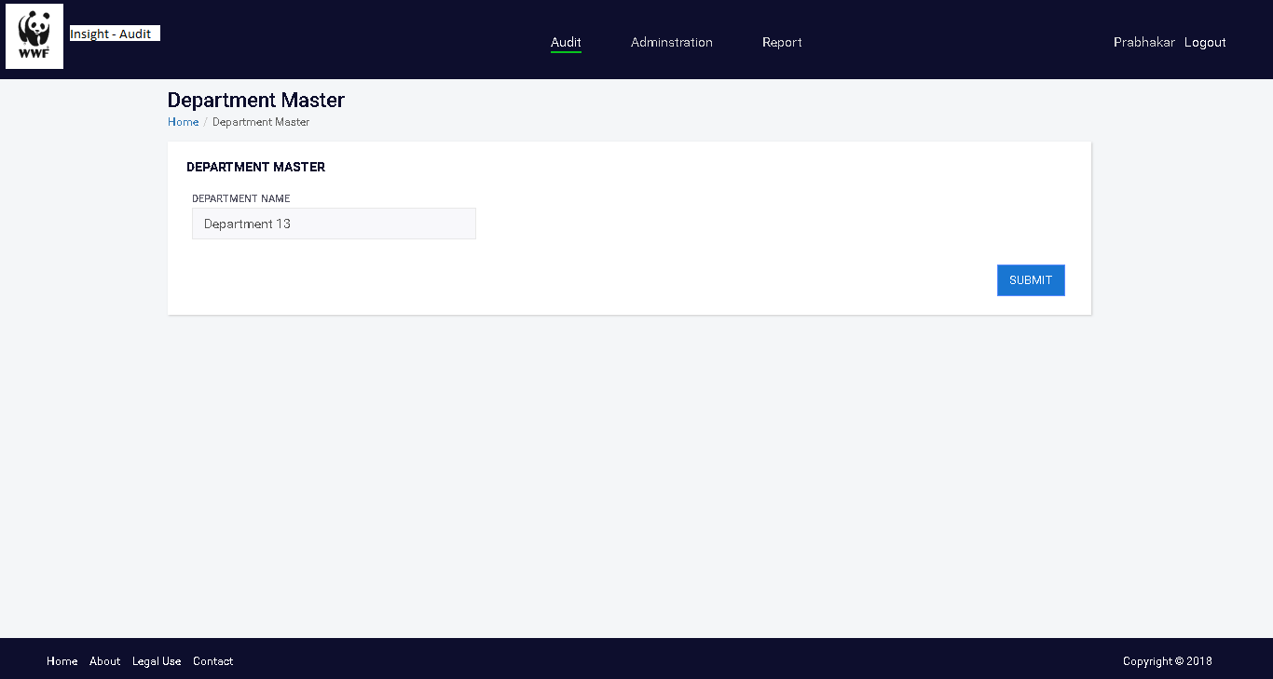

# Audit Department List/Update

As an administrator, need to get the list of Audit Departments created so that the Audit Departments can be viewed and any update should be made.

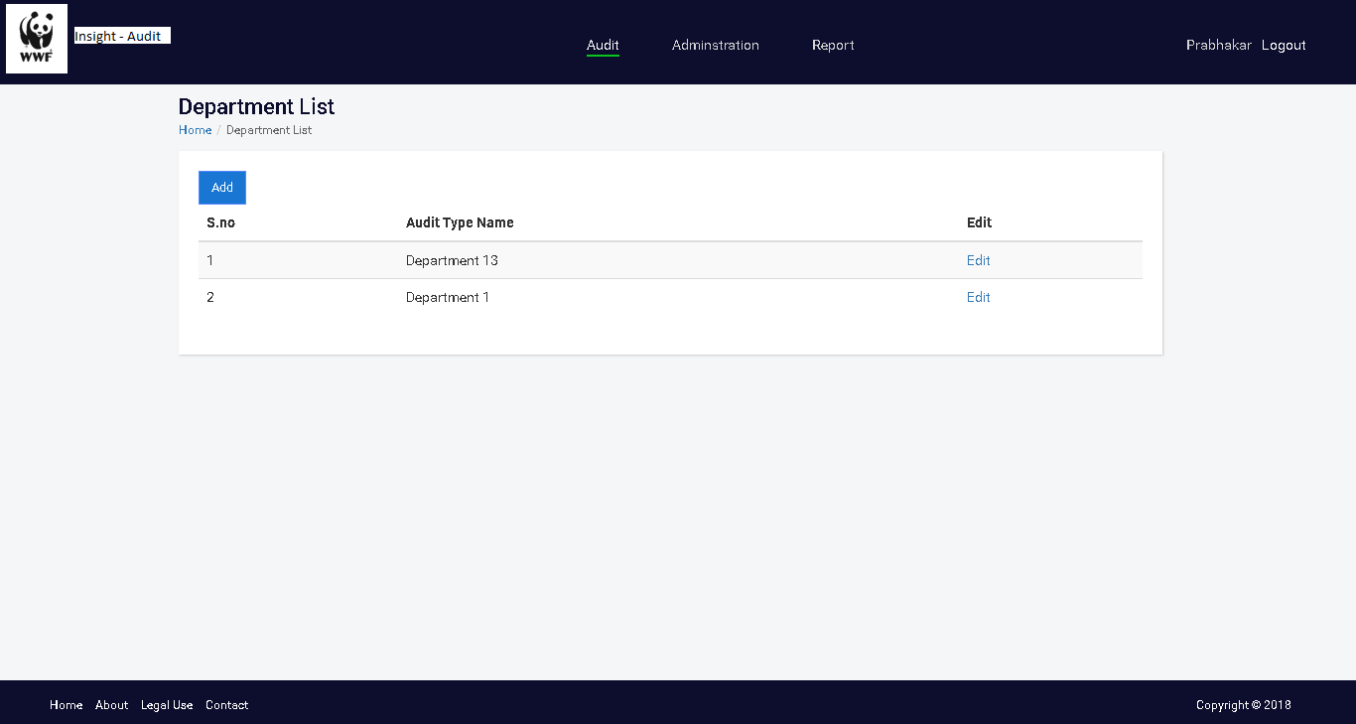

# Audit Add/List/Edit/Search

As an administrator, need to create/list/edit/search the Audit and Assign to respective Manager and Auditor. So that Manager from the Organization and update the recommendations and Auditor can check and close the Audit.

Audit can be searched with these fields

* Audit Title
* Office
* Audit Manager
* Date range
* Status
* Priority

Audit Search Result:

* Open
* Office
* Audit Manager,
* Audit Title
* Target Implantation Date,
* Priority

**Fields for creating Audit**

AUDIT TYPE

ORGANIZATION

ASSIGNED AUDITOR

PRIORITY (RAG)

AUDIT TITLE

AUDIT DATE

RECOMMENDATION

ORIGINAL TARGET DATE

DATE STATUS (RAG)

MANAGEMENT RESPONSE

ASSIGNED MANAGER

DEPARTMENT / ORGANIZATION

MANAGEMENT RESPONSE NOTE

REVISED TARGET DATE

REVISED DATE STATUS (RAG)

PROGRESS UPDATE INFORMATION

AUDIT STATUS

DATE OF CLOSURE

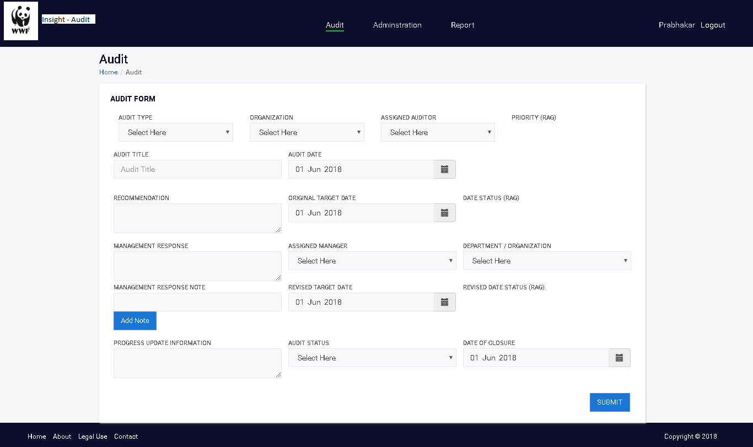

# Listing Office Information

As an administrator, need to view the list of Offices while Audit Add so that the respective Office can be selected.

* Once the user is logged into the system through SSO will show all the Office information owned by the user.

Office info will be fetched from “INSIGHT_OFFICE” table

# Email Notifications

* An Email Notification will be sent when an audit is assigned to Assigned manager
* An Email Notification will be sent when an audit is updated to Assigned manager
* And based on implementation date periodic reminder mails will be sent asking for update from Assigned Manager.

# Reports

As an administrator, need to generate logical Reports so that I can get the status and list of Audit reports etc.

# SSO Integration

SSO need to be implemented on the site so that the users from different WWF sites like Insight, GRR, GTFN can also use the same credentials to login here based on the Roles and permissions set by administrator.

# Database Design

|  |  |  |  |  |
| --- | --- | --- | --- | --- |
| **ARS_AUDIT** | | | | |
| **Fields** | **Type** | **Key** | **Comment** | **Default Value** |
| AUDIT_ID | INT | PK,AI |  |  |
| AUDIT_TITLE | VARCHAR |  |  |  |
| RECOMMENDATION | VARCHAR |  |  |  |
| PROGRESS_UPDATE_INFORMATION | TEXT |  |  |  |
| ASSIGNED_MANAGER_ID | INT | FK['INSIGHT_USER'] |  |  |
| AUDIT_DATE | DATE |  |  |  |
| DEPARTMENT_ID | INT | FK['ARS_DEPARTMENT'] |  |  |
| OFFICE_ID | INT | FK['INSIGHT_OFFICE'] |  |  |
| ORIGINAL_TARGET_IMPLEMENTATION_DATE | DATE |  |  |  |
| ORIGINAL_TARGET_IMPLEMENTATION_RATING_ID | INT | FK['ORIGINAL_TARGET_IMPLEMENTATION_RATING'] |  |  |
| AUDIT_TYPE_ID | INT | FK['ARS_AUDIT_TYPE'] |  |  |
| PRIORITY_LEVEL_ID | INT | FK['ARS_PRIORITY_LEVEL'] |  |  |
| REVISE_TARGET_IMPLEMENTATION_DATE | DATE |  |  |  |
| REVISE_TARGET_IMPLEMENTATION_RATING_ID | INT | FK['REVISE_TARGET_IMPLEMENTATION_RATING'] |  |  |
| AUDIT_RECOMMENTATION_STATUS_ID | INT | FK['ARS_AUDIT_RECOMMENDATION_STATUS'] |  |  |
| CLOSURE_DATE_ID | DATE |  |  |  |
|  |  |  |  |  |
|  |  |  |  |  |
| **ARS_AUDIT_AUDITOR_MAPPING** | | | | |
| **Fields** | **Type** | **Key** | **Comment** | **Default Value** |
| ARS_A_A_MAPPING_ID | INT | PK,AI |  |  |
| AUDIT_ID | INT | FK['ARS_AUDIT'] |  |  |
| USER_ID | INT | FK['INSIGHT_USER'] |  |  |
| USER_ROLE_ID | INT | FK['INSIGHT_ROLE'] | Creator/Viewer/Auditor |  |
|  |  |  |  |  |
|  |  |  |  |  |
| **ARS_MANAGEMENT_RESPONSE** | | | | |
| **Fields** | **Type** | **Key** | **Comment** | **Default Value** |
| MANAGEMENT_RESPONSE_ID | INT | PK,AI |  |  |
| AUDIT_ID | INT | FK['ARS_AUDIT'] |  |  |
| MANAGEMENT_RESPONSE | TEXT |  |  |  |
|  |  |  |  |  |
| **ARS_PRIORITY_LEVEL** | | | | |
| **Fields** | **Type** | **Key** | **Comment** | **Default Value** |
| PRIORITY_LEVEL_ID | INT | PK,AI |  |  |
| PRIORITY_LEVEL | INT |  | Priority level (High- Repeat (Red+),High(Red), Medium(Amber) Low (Green) |  |
|  |  |  |  |  |
| **ARS_AUDIT_RECOMMENDATION_STATUS** | | | | |
| **Fields** | **Type** | **Key** | **Comment** | **Default Value** |
| AUDIT_RECOMMENDATION_STATUS_ID | INT | PK,AI |  |  |
| AUDIT_RECOMMENDATION_STATUS | VARCHAR |  | Open/Closed |  |
|  |  |  |  |  |
| **ARS_DEPARTMENT** | | | | |
| **Fields** | **Type** | **Key** | **Comment** | **Default Value** |
| DEPARTMENT_ID | INT | PK,AI |  |  |
| DEPARTMENT_NAME | VARCHAR |  | Finance  Operations |  |
|  |  |  |  |  |
|  |  |  |  |  |
| **ARS_AUDIT_TYPE** | | | | |
| **Fields** | **Type** | **Key** | **Comment** | **Default Value** |
| AUDIT_TYPE_ID | INT | PK,AI |  |  |
| AUDIT_TYPE_NAME | VARCHAR |  | internal / external / donor |  |
|  |  |  |  |  |
| **ORIGINAL_TARGET_IMPLEMENTATION_RATING** | | | | |
| **Fields** | **Type** | **Key** | **Comment** | **Default Value** |
| ORIGINAL_TARGET_IMPLEMENTATION_RATING_ID | INT | PK,AI |  |  |
| ORIGINAL_TARGET_IMPLEMENTATION_RATING | VARCHAR |  | RAG rated – green: not yet due, amber due in one month, red overdue |  |
|  |  |  |  |  |
| **REVISE_TARGET_IMPLEMENTATION_RATING** | | | | |
| **Fields** | **Type** | **Key** | **Comment** | **Default Value** |
| REVISE_TARGET_IMPLEMENTATION_RATING_ID | INT | PK,AI |  |  |
| REVISE_TARGET_IMPLEMENTATION_RATING | VARCHAR |  | RAG rated – green: not yet due, amber due in one month, red overdue |  |